How to Use Arbortext Macros V1.3

**Use Function Hotkeys:**

Note: These are based on the default settings for the hotkeys.

For the function keys to work, you must have the Arbortext window active for the following macros.

 : CPN Fill

Click in an empty CPN and you can do the following with the F1 Key:

**Press F1 once:** Marco will fill CPN tag with CPN (Single)

**Press F1 twice:** Marco will fill CPN tag with CPN (Plural)

Click in an empty Mod tag

**Press F1 three times:** Marco will fill with Modifier

 +  : Autofill CPN tags in tables

Press this hotkey to start the autofill a table of empty CPN tags.

There is some Initial setup for this to work, the macro will display windows giving instructions for this setup.

This hotkey finds every instance of an empty CPN tag on the screen first and then goes to fill them. Due to this feature, it does not work well with CPN tags in the same line. It is best used for Tables and figure captions.

**Note: Arbortext must be at 100% or above Font scaling/zoom Level to work correctly**

 : Conversions

**Press F2 once:** Marco will put in a units group Tag.

**Press F2 once:** Allow the below process for an already existing Units group tag

Within 10 seconds perform the following actions:

Click in the metric or English tag of the unit group tag and the conversion window will open

Click and hold in the Metric or English tag for about .5 Second within the unit group tag and the Conversion (Tol) window will open

 : Check in – Check out- Validate

**Press F3 once:** Check Out operation in Arbortext

**Press F3 twice:** Check In operation in Arbortext

**Press F3 three times:** Validate operation in Arbortext

 : Figure Search window

This macro will run differently depending on which program you press the hotkey in.

If in Windchill Canvas:

**Press F4 Twice:** Check in Graphic (Same as pressing F2 then F (Close2wc))

If in the Arbortext window

**Press F4** **Once**: Macro will open Search window and set it up automatically for a figure search

**Note:** If the Gnumber (g00000001) is already copied to the clipboard it will paste the number into the figure search window.

If in the Canvas Service window (Canvas check-in window)

**Click anywhere in the figure g-number spot**

**Press F4 once:** Macro will move to Arbortext to open and set up the search window and paste the Gnumber the window, then move back to the Canvas window and Enter the Section (Ex. 72A,68E, Etc.) that you have in the “1 Press” option in the Arbortext Macros program options.

**Press F4 twice:** Macro will move to Arbortext to open and set up the search window and paste the Gnumber the window, then move back to the Canvas window and Enter the Section (Ex. 72A,68E, Etc.) that you have in the “2 Press” option in the Arbortext Macros program options.

**Press F4 three times:** Macro will move to Arbortext to open and set up the search window and paste the Gnumber the window, then move back to the Canvas window and Enter the Section (Ex. 72A,68E, Etc.) that you have in the “3 Press” option in the Arbortext Macros program options.

**NOTE: For the F5 hotkey below macro will display a window (shown below) that has a copy text button on it. Click that button to copy the required information, and then paste that information in the location you want to table.**

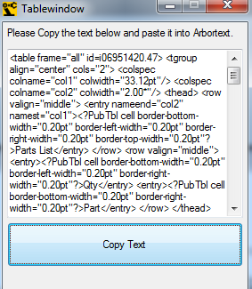

 : Column wide Tables Hotkey

**Press F5 once:** Opens a Window to display options for table creation

 +  +  : Warnings Search

This will open a new window allowing you to select which category of warning you want to search for. Once you double click on your selection, or select a category and press Ok, the search window in Arbortext will open and setup for a warning search.

 +  : Arbortext Window to Front

This hotkey will make the Arbortext window the active window and bring the window to the front.

 +  : Browser Window to Front

This hotkey will make the Browser window (If exists) the active window and bring the window to the front.

 +  : Canvas Window to Front

This hotkey will make the Windchill Canvas window (If exists) the active window and bring the window to the front.

 +  : Windchill – Home Window to Front

This hotkey will make the ACM home screen window (If exists or active tab) the active window and bring the window to the front.

**Hotkey Quick View Menu**

Press  +  (In that order) to bring up the quick view menu. You can also double click on the Tray icon in the taskbar to bring up the menu. This menu will display the hotkeys and has tabs for Options, Change Log, and About information. This window will automatically close after a few seconds of clicking off of it.

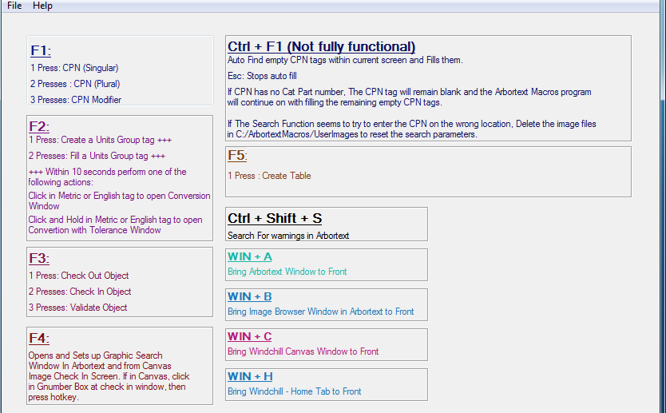

This Quickview menu will show the hotkeys. The Hotkeys in this screen will change with the User selected Hotkey in the Options Tab.

**Hotkey Quick View Menu: Options**

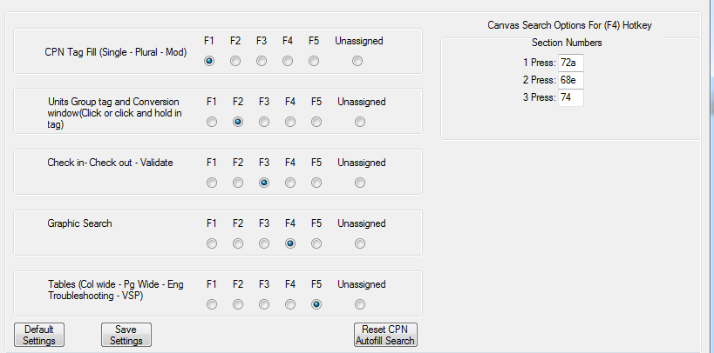

When a change is made to the hotkeys, if there is already another function assigned to that hotkey, the old function will automatically move to unassigned and become disabled to prevent any issues.

To re-enable hotkeys, just assign them to one of the Function keys

There is a Default Setting button that resets the hotkeys to the default settings.

There is a Reset CPN Autofill search button. When this is pressed, it will delete all data files associated with the autofill function. Press this button if the autofill is messing up. (Trying to fill in empty areas where no tag is present, or not selecting the empty CPN tags properly)

The Canvas Search Options section allows you to preset 3 different sections for the Canvas check in section of the Canvas Image check in screen.

**Arbortext Bookmark Menu**

Press left mouse button + right mouse button to bring up the following menu in Arbortext.

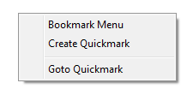

Bookmark Menu will open the bookmark menu in Arbortext to create/ goto bookmarks to help navigate long documents. Same as pressing Ctrl + Shift + F5 in Arbortext

Create Quickmark will create a quickmark in Arbortext to easily jump back to if you go to a different part of the document (only one quickmark can be made at a time. If a new quickmark is created, the previous one will be removed). Same as Pressing Ctrl + Shift + Q in Arbotext

Goto Quickmark will go to the quickmark that was created in the document. Same as pressing Ctrl + Q in Arbortext